Ricci Lam

A12992490

Physics 2CL

Section A08

12/3/16

Lab 6 Report

**Worksheet**

1. There is no further excitation of the circuit after the battery is turned off when the circuit is over damped or at critical resistance. There is further excitation when the circuit is under damped. The resistance is high enough, the energy dissipated by the resistor will quickly bring the voltage in the circuit to zero by dissipating energy quickly to the point that there is no chance for oscillation to happen because the energy that would otherwise be applied to oscillations is dissipated by the resistor. In the other hand, oscillation is allowed in an underdamped circuit because the energy is not dissipated fast enough. The alternating storage and change of energy between the inductor and the capacitor will then create oscillating motion.
2. This moment in time can be described with a differential equation from Kirchhoff’s law for the DC RLC Circuit:

VS-VR-VC-VL=0

VS= iR+ (1/C) ∫idt + L(di/dt)

Vs= R(di/dt) + (1/C)I + L((d2i)/(dt2))

Voltage across resistor: VR=i(t)R

Voltage across capacitor: VC=(1/C) ∫i(t)dt

Voltage across inductor: VL=L(di/dt)

Based on this equation breakdown, the voltage at the resistor at t=0 is VR = i(0)R , the voltage across the Capacitor is VC=(1/C) ∫i(t)dt, and the voltage around the inductor at t=0 is VL = L(di/dt). In all of these scenarios, the voltage is dependent on the current generated at a given time (t=0 in this case).

1. **Analysis**

Section 3.1

C = 10.11 ± 0.01 µF L = 7.96 ± 0.01 mH RL = 5.6 ± 0.1 Ω

Section 3.2

Decade Box Resistance: 1.20 ± 0.01 Ω

Total resistance: 7.96 + 1.20 = 10.16 Ω

(Addition, error is additive)

0.01 + 0.01 = 0.02 Ω 🡪 Total Resistance = 10.16 ± 0.02 Ω = Rt

= 638.2 s

$δτ= \sqrt{{((\frac{dτ}{dR})(δR))}^{2}+{((\frac{dτ}{dL})(δL))}^{2}}$ $\frac{dτ}{dR}=\frac{1}{2L}$ $\frac{dτ}{dL}= \frac{-R}{2L^{2}}$

$δτ= \sqrt{{((\frac{1}{2L})(δR))}^{2}+{((\frac{-R}{2L^{2}})(δL))}^{2}}$

1.49 s $= \sqrt{{((\frac{1}{2\left(0.00796 H\right)})(0.02 Ω))}^{2}+{((\frac{-10.16 Ω}{2{\left(0.00796 H\right)}^{2}})(0.00001 H))}^{2}}$

τ = 638.2 ± 1.5 s

$ω_{D}= \sqrt{\frac{1}{LC}-\frac{R^{2}}{4L^{2}}}$ $\frac{dω_{D}}{dC}=$ $-\frac{1}{C^{2}L\sqrt{\frac{4L-R^{2}C}{CL^{2}}}}$ $\frac{dω_{D}}{dL}= \frac{\frac{R^{2}}{2L^{3}}-\frac{1}{CL^{2}}}{2\sqrt{\frac{1}{LC}-\frac{R^{2}}{4L^{2}}}}$ $\frac{dω_{D}}{dR}= \frac{-R}{4L^{2}\sqrt{\frac{1}{LC}-\frac{R^{2}}{4L^{2}}}}$

$3.52×{10}^{3}\frac{rad}{s}= \sqrt{\frac{1}{(0.00796 H)(10.11×{10}^{-6} F)}-\frac{{10.16 Ω}^{2}}{4{(0.00796 H)}^{2}}}$ =3519.38

Δ $ω_{D}$ = $\sqrt{{\left(\left(\frac{dω_{D}}{dR}\right)\left(δR\right)\right)}^{2}+{\left(\left(\frac{dω_{D}}{dL}\right)\left(δL\right)\right)}^{2}+{\left(\left(\frac{dω_{D}}{dC}\right)\left(δC\right)\right)}^{2}}$

Relative Error Used = 🡪 ± 200 (rad/s)

The error from the regular calculation was determined to be unreasonably large, therefore, relative error was used to get the error of the calculation to within reasonable limits

ωD = (3.5 ± 0.2 (rad/s))x103

Voltage-Time Pairs

|  |  |
| --- | --- |
| Time (s) | Voltage (V) |
| 1.1185 = t1 | 0.01416 = V1 |
| 1.1193 = t2 | -0.00968 = V2 |
| 1.1202 = t3 | 0.00371 = V3 |
| 1.1210 = t4 | -0.00195 = V4 |

6 pairs:

$$τ= \frac{t_{N}-t_{M}}{ln\left|V_{M}\right|-ln\left|V_{N}\right|}$$

|  |  |  |  |  |  |
| --- | --- | --- | --- | --- | --- |
| TM,tN  (M,N) | TM (s) | TN (s) | VM (V) | VN (V) | τ (s) |
| (1,2) | 1.1185 | 1.1193 | 0.01416 | -0.00968 | 0.0021 |
| (1,3) | 1.1185 | 1.1202 | 0.01416 | 0.00371 | 0.0012 |
| (1,4) | 1.1185 | 1.1210 | 0.01416 | -0.00195 | 0.0012 |
| (2,3) | 1.1193 | 1.1202 | -0.00968 | 0.00371 | 0.0009 |
| (2,4) | 1.1193 | 1.1210 | -0.00968 | -0.00195 | 0.0011 |
| (3,4) | 1.1202 | 1.1210 | 0.00371 | -0.00195 | 0.0012 |

|  |  |  |  |
| --- | --- | --- | --- |
| TM,TN (M,N) | TM (s) | TN (s) | ωD (rad/s) |
| (1,2) | 1.1185 | 1.1193 | 3927.0 |
| (1,3) | 1.1185 | 1.1202 | 3696.0 |
| (1,4) | 1.1185 | 1.1210 | 3769.9 |
| (2,3) | 1.1193 | 1.1202 | 3490.7 |
| (2,4) | 1.1193 | 1.1210 | 3696.0 |
| (3,4) | 1.1202 | 1.1210 | 3927.0 |

τ = 0.0013 ± 0.0004 s

0.0013s = $\frac{0.0021+0.0012+0.0012+0.0009+0.011+0.0012}{6}$

0.00042s = $\sqrt{\frac{{(0.0013-0.0021)}^{2}+{(0.0013-0.0012)}^{2}+{(0.0013-0.0012)}^{2}+{(0.0013-0.0009)}^{2}+{(0.0013-0.0011)}^{2}+{(0.0013-0.0012)}^{2}}{6-1}}$

ωD = 3.75 x 103 ± 1.6 x 103 (rad/s)

3751.1 (rad/s) = $\frac{3927.0+3696.0+3769.9+3490.7+3696.0+3927.0}{6}$

164.99408 (rad/s) = $\sqrt{\frac{{(3751.1-3927)}^{2}+{(3751.1-3696)}^{2}+{(3751.1-3769.9)}^{2}+{(3751.1-3490.7)}^{2}+{(3751.1-3696)}^{2}+{(3751.1-3927)}^{2}}{6-1}}$

$t= \frac{\left|t_{theo}-t_{expt}\right|}{\sqrt{δ_{theo}^{2}+δ_{expt}^{2}}}$

For τ = 425.33

For ωD = 0.6959

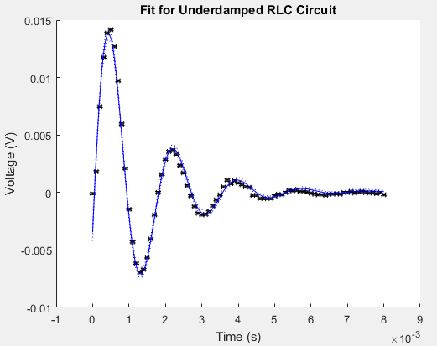

Parameter A = 1.934810e-02 +/- 5.060054e-04

Parameter B = 1.356353e-03 +/- 4.646059e-05

Parameter C = 3.554454e+03 +/- 2.054257e+01

Parameter D = -1.841907e-01 +/- 1.780011e-02

Parameter E = 7.132632e-05 +/- 6.255808e-05

A = Max Voltage = 1.93x10-2 ± 0.05x10-2 V

B = Tau = 1.36x10-3 ± 0.05x10-3 s

C = Frequency = 3.55x103 ± 20 rad/s

D = Phase Shift = -0.18 ± 0.02 rad 🡪 Should be Zero

E = Vertical Shift = 7x10-5 ± 6x10-5 V 🡪 Should be Zero

The Exponent sin was chosen because it contained an oscillation that neither of the other two contained and also it had a decay style that matched a reverse exponential function.

$t= \frac{\left|t_{fit}-t_{expt}\right|}{\sqrt{δ_{fit}^{2}+δ_{expt}^{2}}}$

tω = 1.18

tτ = 0.14

Section 3.3

R = 50.5 ± 0.1 Ω Rt = 50.5 + 7.96 = 58.5 Ω (0.01 + 0.1 = 0.11)🡪 58.5 ±0.1Ω

$τ= \frac{2L}{R}$ $τ= \frac{2(0.00796 H)}{58.5Ω}$ = 3.67 x 103 s

= 6.28 s

τ = 3674 ± 6 s

ωD =

ωD = = 3854.5 rad/s

Δ $ω_{D}$ = $\sqrt{{\left(\left(\frac{dω_{D}}{dR}\right)\left(δR\right)\right)}^{2}+{\left(\left(\frac{dω_{D}}{dL}\right)\left(δL\right)\right)}^{2}+{\left(\left(\frac{dω_{D}}{dC}\right)\left(δC\right)\right)}^{2}}$

Relative Error Used = 🡪 ± 8.9975 (rad/s)

ωD = 3854 ± 9 rad/s

Note that actual error was unreasonably large, therefore, relative error was used in its place for better understanding of numbers.

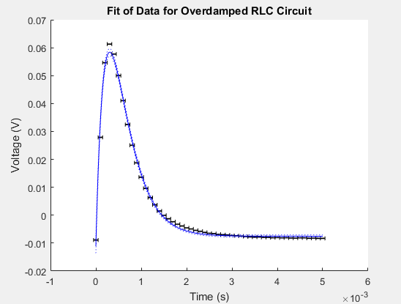

Parameter A = 9.650109e-01 +/- 1.968676e-02

Parameter B = 2.962068e-04 +/- 3.203391e-06

Parameter C = 6.353713e+02 +/- 2.872688e-05

Parameter D = -3.691185e-03 +/- 1.251846e-03

Parameter E = -7.521869e-03 +/- 2.298048e-04

A = Max Voltage = 0.97 ± 0.02 V

B = tau = 2.96x10-4 ± 0.03x10-4 s

C = “Frequency” argument =635.37130 ± 3x10-5 rad/s

D = Phase shift =-4x10-3 ± 1x10-3 rad 🡪 should be zero

E = Vertical shift = -0.0075 ±0.0002 V 🡪 should be zero

The sinh exponential fit was chosen because it fit the best of all possible tried fits and also because the fitting guide instructed us to do so.

$t= \frac{\left|t_{fit}-t_{expt}\right|}{\sqrt{δ_{fit}^{2}+δ_{expt}^{2}}}$

tω = 536.58

tτ = 3.45x10-6

Section 3.4

Rcrit = 2√(L/C) 56.1 Ω = 2√((0.00796 H)/(10.11 ×〖10〗^(-6) ))

Rupper = 33.1 Ω Rlower = 31.1 Ω

Ravg = 33.1+31.1 = 32.1 ± 1 Ω

Ractual = Ravg + RL = 32.1 + 7.96 = 40.1 ± 1.1 Ω\

t= |t_theo-t_expt |/√(δ_theo^2+δ_expt^2 ) = 16.00

Section 4

C = 10.24 ± 0.01 µF L = 8.2 ± 0.1 mH RL = 7.7 ± 0.1 Ω RD = 10.0 ± 0.1 Ω

Rt = RL + RD 7.7 + 10.0 = 17.7 ± 0.2 Ω

= 21.1

ω0 = 3.45 x 103 ± 0.02 x 103 = Theoretical

ω0 = 3.64 x 103 ± 0.06 x 103 = experimental

$Q= \sqrt{\frac{L}{C}}\frac{1}{R}$ $1.60= \sqrt{\frac{(0.0082 H)}{(10.24×{10}^{-6} F)}}\frac{1}{17.7 Ω}$

$δQ= \sqrt{{((\frac{-\sqrt{L}}{\sqrt{C}R^{2}})(δR))}^{2}+{(\left(\frac{-\sqrt{\frac{L}{C}}}{2CR}\right)\left(δC\right))}^{2}+{(\left(\frac{\sqrt{\frac{L}{C}}}{2LR}\right)\left(δL\right))}^{2}}$ = 0.02

Qtheo = 1.60 ± 0.02

$Q_{expt}= \frac{ω_{0}}{ω_{+}-ω_{-}}= \frac{3644.247}{5340.708-2513.274}=1.29$

$δQ= \sqrt{{(\left(\frac{1}{ω_{+}-ω_{-}}\right)\left({δω}_{0}\right))}^{2}+{(\left(\frac{{-ω}_{0}}{{(ω_{+}-ω_{-})}^{2}}\right)\left(δω_{+}\right))}^{2}+{(\left(\frac{ω_{0}}{{(ω_{+}-ω_{-})}^{2}}\right)\left(δω_{-}\right))}^{2}}$ = 8.09

Qexpt = 1.29 ± 8.09

$t= \frac{\left|t_{theo}-t_{expt}\right|}{\sqrt{δ_{theo}^{2}+δ_{expt}^{2}}}$ tω = 2.91 tQ = 0.038

Data Table

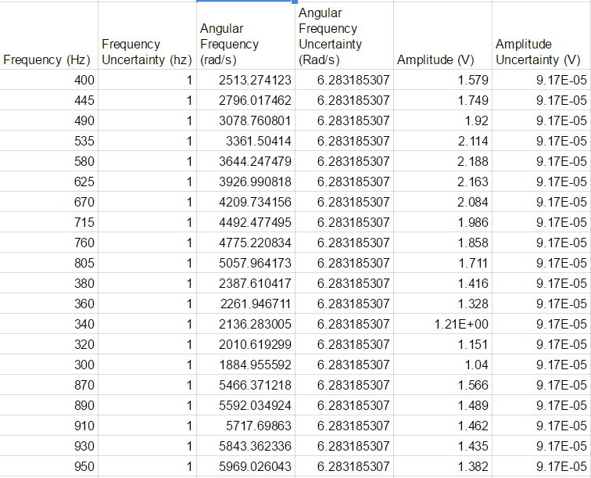

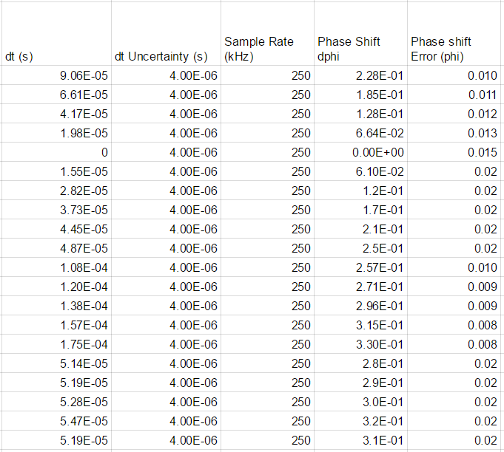

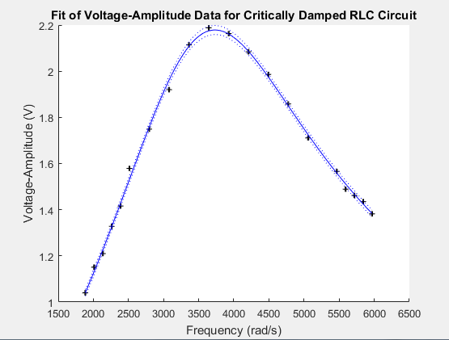

Parameter A = 2.178479e+00 +/- 9.285133e-03

Parameter B = 1.248333e+00 +/- 1.359231e-02

Parameter C = 3.731421e+03 +/- 9.074958e+00

A = Max Voltage = 2.179 ± 0.009 V

B = Quality factor = 1.248 ± 0.014

C = Resonant Frequency = 3731 ± 9 rad/s

The Square Root Fit was chosen because the data matched a reverse square root equation with the curve going in the opposite way in both meanings

$t= \frac{\left|t_{fit}-t_{expt}\right|}{\sqrt{δ_{fit}^{2}+δ_{expt}^{2}}}$

tω = 1.43

tQ = 0.0006112

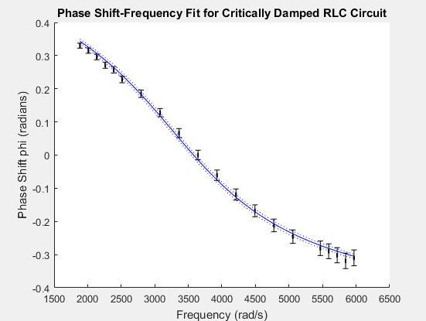

Parameter A = 1.733003e-04 +/- 3.268934e-06

Parameter B = 3.577687e+03 +/- 1.772381e+01

A = Tau = 1.73x10-4 ± 0.03x10-4 s

B = Resonant Frequency = 3578 ± 18 rad/s

$t= \frac{\left|t_{fit}-t_{expt}\right|}{\sqrt{δ_{fit}^{2}+δ_{expt}^{2}}}$

tω = 1.05

tτ = 0.003632

Discussion

1. It is mathematically possible to detect the oscillations by the use of a second derivative. The second derivative measures when there is a change in the concavity of the slope. Oscillations can be detected where the concavity (or second derivative) is close or equal to zero (or we can use the cut-off value of 1 x 10-4), and if the concavity breaks zero, there is evidence for oscillation. When the circuit is over damped or critically damped, there would be no changes in the concavity (or the sign of the slope) near the point where the voltage bottoms out. In an underdamped system, since there are changes to the sign of the slope, there is also a sign change in the concavity. For reference, there is only one change in the sign of the second derivative after the battery is turned off if the circuit is over damped or critically damped. There will be multiple changes when the circuit is underdamped.